Karl Marx and Friedrich Engels:
The Communist Manifesto (1848)
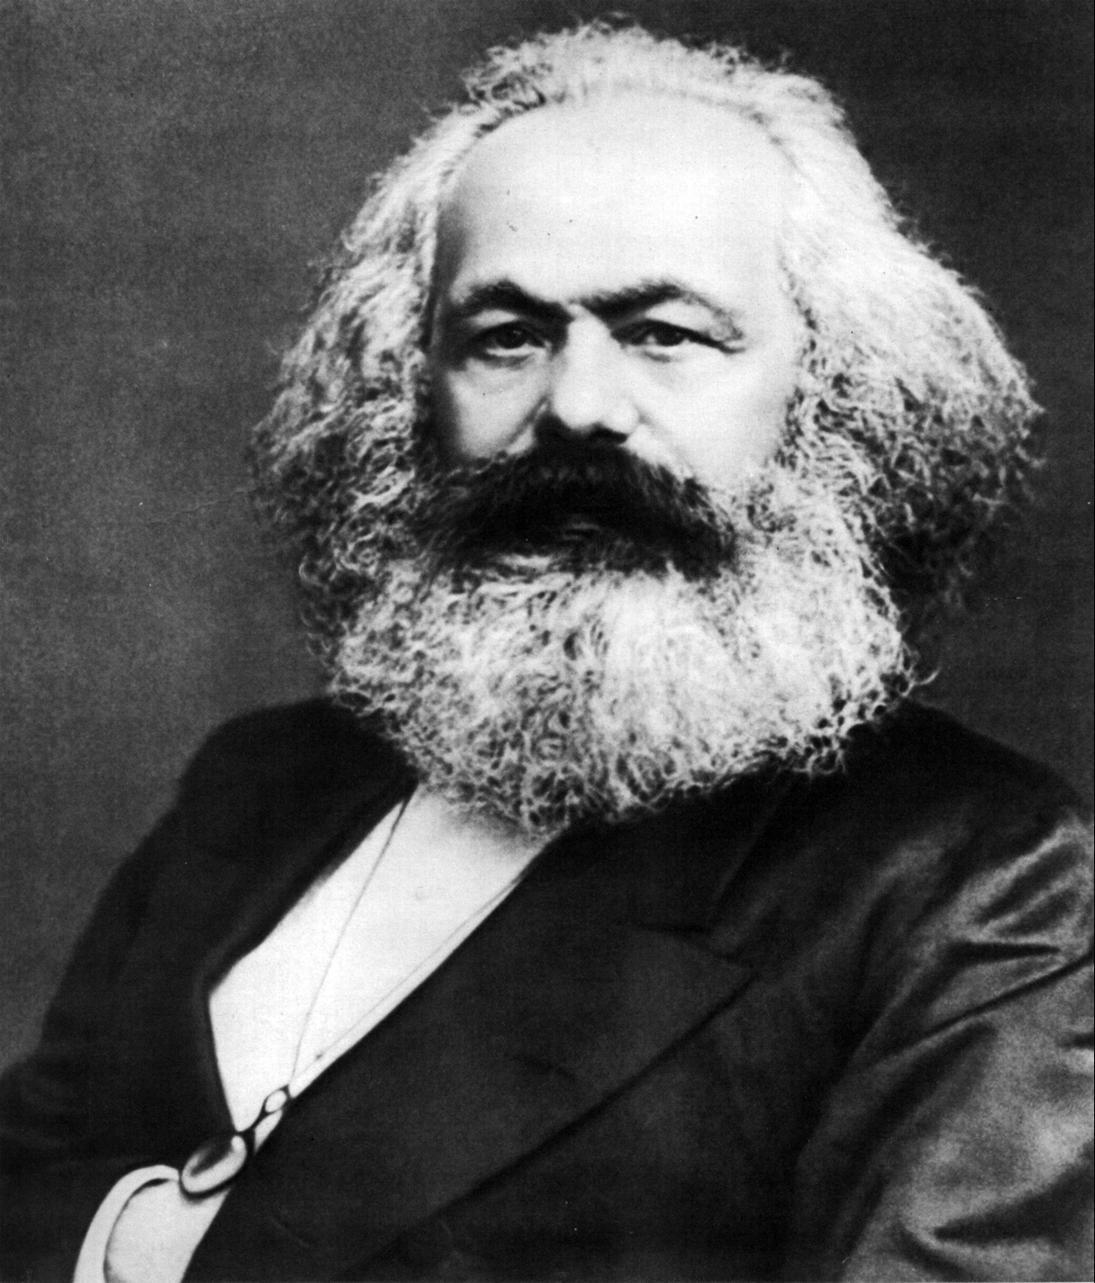

Although it at first had little or no impact on the widespread and varied revolutionary movements of the mid-19th century Europe, the Communist Manifesto was to become one of the most widely read and discussed documents of the 20th century. Marx sought to differentiate his brand of socialism from others by insisting that it was scientifically based in the objective study of history, which he saw as being a continuous process of change and transformation. Just as feudalism had naturally evolved into mercantilism and then capitalism, so capitalism would inevitably give way to its logical successor, socialism (a term which in Marx's usage includes its most advanced form, communism) as the necessary result of class struggle. Marx's insistence that tough-minded realism should replace the utopian idealism of earlier socialists had profound consequences: it enabled revolutionaries like Lenin to be put it into action, but it also tended to encourage its followers to accept ruthless means to justify what they believed were historically necessary ends. Radical politics were being much more widely discussed than the small number of radicals justified; but Marx uses this fact to his advantage by proclaiming that any ideology so feared must be important and worth explaining clearly. In the notes, "Marx" is used as shorthand for both Marx (the theoretician) and Engels (the more eloquent writer of the two).The Manifesto was originally issued in several languages, including this English version.

Prologue
A specter is haunting Europe--the specter of communism. All the powers of old Europe have entered into a holy alliance to exorcise this specter: Pope and Czar, Metternich and Guizot, French Radicals and German police spies.
Where is the party in opposition that has not been decried as communistic by its opponents in power? Where the Opposition that has not hurled back the branding reproach of communism, against the more advanced opposition parties, as well as against its reactionary adversaries?
Two things result from this fact:
I. Communism is already acknowledged by all European powers to be itself a power.
II. It is high time that Communists should openly, in the face of the whole world, publish their views, their aims, their tendencies, and meet this nursery tale of the specter of communism with a manifesto of the party itself.

Part I: Bourgeois And Proletarians
The history of all hitherto existing society is the history of class struggles.
Freeman and slave, patrician and plebeian, lord and serf, guildmaster and journeyman, in a word, oppressor and oppressed, stood in constant opposition to one another, carried on an uninterrupted, now hidden, now open fight, a fight that each time ended, either in a revolutionary reconstitution of society at large, or in the common ruin of the contending classes.
In the earlier epochs of history, we find almost everywhere a complicated arrangement of society into various orders, a manifold gradation of social rank. In ancient Rome we have patricians, knights, plebeians, slaves; in the Middle Ages, feudal lords, vassals, guild-masters, journeymen, apprentices, serfs; in almost all of these classes, again, subordinate gradations.
The modern bourgeois society that has sprouted from the ruins of feudal society, has not done away with class antagonisms. It has but established new classes, new conditions of oppression, new forms of struggle in place of the old ones.
Our epoch, the epoch of the bourgeoisie, possesses, however, this distinctive feature: It has simplified the class antagonisms. Society as a whole is more and more splitting up into two great hostile camps, into two great classes directly facing each other--bourgeoisie and proletariat. . . .
Modern industry has established the world market, for which the discovery of America paved the way. This market has given an immense development to commerce, to navigation, to communication by land. This development has, in its turn, reacted on the extension of industry; and in proportion as industry, commerce, navigation, railways extended, in the same proportion the bourgeoisie developed, increased its capital, and pushed into the background every class handed down from the Middle Ages.
We see, therefore, how the modern bourgeoisie is itself the product of a long course of development, of a series of revolutions in the modes of production and of exchange.
Each step in the development of the bourgeoisie was accompanied by a corresponding political advance of that class. An oppressed class under the sway of the feudal nobility, it became an armed and self-governing association in the medieval commune; here independent urban republic (as in Italy and Germany), there taxable "third estate" of the monarchy (as in France); afterwards, in the period of manufacture proper, serving either the semi-feudal or the absolute monarchy as a counterpoise against the nobility, and, in fact, cornerstone of the great monarchies in general--the bourgeoisie has at last, since the establishment of modern industry and of the world market conquered for itself, in the modern representative state, exclusive political sway. The executive of the modern state is but a committee for managing the common affairs of the whole bourgeoisie.
The bourgeoisie has played a most revolutionary role in history.
The bourgeoisie, wherever it has got the upper hand, has put an end to all feudal, patriarchal, idyllic relations. It has pitilessly torn asunder the motley feudal ties that bound man to his "natural superiors," and has left no other bond between man and man than naked self-interest, than callous "cash payment." It has drowned the most heavenly ecstasies of religious fervor, of chivalrous enthusiasm, of philistine sentimentalism, in the icy water of egotistical calculation. It has resolved personal worth into exchange value, and in place of the numberless indefeasible chartered freedoms, has set up that single, unconscionable freedom--Free Trade. In one word, for exploitation, veiled by religious and political illusions, it has substituted naked, shameless, direct, brutal exploitation.

Part II: Proletarians and Communists
What else does the history of ideas prove, than that intellectual production changes its character in proportion as material production is changed? The ruling ideas of each age have ever been the ideas of its ruling class.
When people speak of ideas that revolutionize society, they do but express the fact that within the old society the elements of a new one have been created, and that the dissolution of the old ideas keeps even pace with the dissolution of the old conditions of existence.
When the ancient world was in its last throes, the ancient religions were overcome by Christianity. When Christian ideas succumbed in the eighteenth century to rationalist ideas, feudal society fought its death-battle with the then revolutionary bourgeoisie. The ideas of religious liberty and freedom of conscience, merely gave expression to the sway of free competition within the domain of knowledge.
"Undoubtedly," it will be said, "religion, moral, philosophical and juridical ideas have been modified in the course of historical development. But religion morality, philosophy, political science, and law, constantly survived this change."
"There are, besides, eternal truths, such as Freedom, Justice, etc., that are common to all states of society. But communism abolishes eternal truths, it abolishes all religion, and all morality, instead of constituting them on a new basis; it therefore acts in contradiction to all past historical experience."
What does this accusation reduce itself to? The history of all past society has consisted in the development of class antagonisms, antagonisms that assumed different forms at different epochs.
But whatever form they may have taken, one fact is common to all past ages, viz., the exploitation of one part of society by the other. No wonder, then, that the social consciousness of past ages, despite all the multiplicity and variety it displays, moves within certain common forms, or general ideas, which cannot completely vanish except with the total disappearance of class antagonisms.
The Communist revolution is the most radical rupture with traditional property relations; no wonder that its development involves the most radical rupture with traditional ideas.

Part IV: Position of the Communists in Relation to the Various Existing Opposition Parties
In short, the Communists everywhere support every revolutionary movement against the existing social and political order of things.
In all these movements they bring to the front, as the leading question in each case, the property question, no matter what its degree of development at the time.
Finally, they labor everywhere for the union and agreement of the democratic parties of all countries.
The Communists disdain to conceal their views and aims. They openly declare that their ends can be attained only by the forcible overthrow of all existing social conditions. Let the ruling classes tremble at a Communist revolution. The proletarians have nothing to lose but their chains. They have a world to win.
Workingmen of all countries, unite!
______________________________________________________________________________
This is an excerpt from Reading About the World, Volume 2, edited by Paul Brians, Mary Gallwey, Douglas Hughes, Azfar Hussain, Richard Law, Michael Myers, Michael Neville, Roger Schlesinger, Alice Spitzer, and Susan Swan and published by Harcourt Brace Custom Books.
The reader was created for use in the World Civilization course at Washington State University, but material on this page may be used for educational purposes by permission of the editor-in-chief:
Paul Brians
Department of English
Washington State University
Pullman 99164-5020

Austrian and French Conservative leaders
Marx opposed secret conspiratorial communist organizations because he felt that the only successful revolution would need the support of the overwhelming mass of society; and people could not be expected to support what they did not understand or even know about.
Typical of ancient civilizations like that of the Greeks.
Roman social classes.
From the Middle Ages.
Representing the Later Middle Ages and the Renaissance.
The term originally meant simply the class of people who lived in cities, but here it means those whose income comes from doing business rather than--like the aristocracy--from inherited estates or--like the proletariat--from wages.
The working class, people who make their living by working for others rather than owning or investing in businesses.
Marx's comments on the importance of the world market, developed further in passages here omitted, sounds very modern. He argued that the differences between countries would diminish as they adopted capitalism and increased their international trade, paving the way for a stateless world united in communism.
Marx particularly has in mind the European revolutions of 1789-1848, in which the bourgeoisie, which had long before become the dominant economic force in society, asserted its claims to political power as well.
In this famous comment, the modern democratic states are dismissed as mere tools of the bourgeoisie, since it is the wealthy who run them and set their agendas, despite their claims to popular representation.
Although the following paragraph outlines this role in negative terms, Marx believed that the transformation of the world wrought by capitalism was absolutely necessary to provide the foundations for communism; so the bourgeoisie are revolutionary in fact, though unwittingly so.
Although this is harshly put, Marx believes that the idealism which justified earlier class structures was indeed an illusion, a repressive deception that needed to be destroyed.
One of Marx's most influential concepts. In a capitalist society people think competition natural because capitalism requires competition; but in the Middle Ages submission to one's social "superiors" was seen as equally natural. Communism is not "against human nature" because there is no such thing--only the social values produced by certain kinds of economic organization. Contemporary Marxist analysis attempts to trace society's values back to the economic and political interests of the most powerful people in society.
Marx spent relatively little time outlining the nature of communist society, but the goals were widely understood to be 1) complete equality of all citizens, 2) abolition of private ownership of the means of production (factories, mines, railways, etc.), 3) the replacement of a market economy with one in which everyone got whatever they needed in return for such labor as they were able to give. In addition, Marx envisions the abolition of all states and governments, and as a consequence, an end to war. The crucial problem of how one motivates workers in a state which is both free and propertyless was never solved by the Marxist states of the 20th century.
Marx argues that communist should work with all "progressive" movements in what were later to be called "united fronts."
Note the repeated emphasis on openness. When communists were viewed as conspirators they risked being seen as enemies of the people they were trying to help.
This stirring conclusion is almost always misquoted as "Working men of all countries, unite! You have nothing to lose but your chains!"

